SERENITY FOUNDATION
A MINOR PROJECT REPORT

submitted by
NAIR SWAPNA SASIDHARAN
Register No: KH.EN.I5MCA22062
AKSHAYA POOJA A P
Register No: KH.EN.I5MCA22014
PARVATHY NAIR S
Register No: KH.EN.I5MCA22076

Under the supervision of
Mrs. APARNA PV

Department of Computer Science and IT
in partial fulfilment of the requirement of
AMRITA VISHWA VIDYAPEETHAM
for the award of the degree of
FIVE YEAR INTEGRATED MCA


AMRITA VISHWA VIDYAPEETHAM, KOCHI CAMPUS
November 2024
AMRITA VISHWA VIDYAPEETHAM


BONAFIDE CERTIFICATE
This is to certify that the project report entitled SERENITY FOUNDATION submitted by NAIR SWAPNA SASIDHARAN register no: KH.EN.I5MCA22062 , AKSHAYA POOJA
AP register no:KH.EN.I5MCA22014 and PARVATHY NAIR S register no:KH.EN.I5MCA22076 in partial fulfilment of the requirements for the award of DEGREE OF FIVE YEAR INTEGRATED MCA is a bonafide record of the work carried out under my guidance and supervision at school of computing Amrita Vishwa Vidhyapeetham, Kochi Campus.

APARNA PV DR. SANGEETHA J
Project Advisor Head of the Department
Faculty Associate Department of Computer Science
Department of Computer Science School of Computing
School of Computing Amrita Vishwa Vidyapeetham
Amrita Vishwa Vidyapeetham Kochi Campus
Kochi Campus

The project was evaluated as on:

Internal Examiner External Examiner

DECLARATION

We affirm that the project work entitled “SERENITY FOUNDATION” being submitted in partial fulfilment for the award of the DEGREE OF FIVE YEAR INTEGRATED MCA is the original work carried out by us. It has not formed the part of any other project work submitted for the award of any degree or diploma, either in this or any other University.

Nair Swapna Sasidharan
Register No: KH.EN.I5MCA22062
Akshaya Pooja A P
Register No: KH.EN.I5MCA22014
Parvathy Nair S
Register No: KH.EN.I5MCA22076

Place: Kochi
Date:

DEDICATION

To

My parents, all my teachers and the eternal God. Thank you for believing in me and encouraging me throughout.

ACKNOWLEDGEMENT

A venture can’t be completely by itself. We take this opportunity to gratefully acknowledge various people who acted as guides along the way.

We offer our humble salutations at the lotus feet of holy mother Sri Mata Amritanandamayi Devi, who is the guiding light of our life without which we would not have completed our project.

The success of any work requires the blessings of the Lord Almighty. We thank our God for aiding us in our travel to success.

We express our thankfulness to Dr. U .Krishnakumar , Director, Amrita Vishwa Vidyapeetham, Kochi Campus for giving us an opportunity to do our minor project.

We would like to express our deep gratitude to Dr. Sangeetha J, Head of the Department, Computer Science and IT, School of Computing, Amrita Vishwa Vidyapeetham, Kochi Campus for her valuable guidance and for the support she rendered to us.

We would also like to thank our guide Aparna PV, Faculty Associate, who revised our ideas and helped us to successfully complete the minor project.

We would also like to express our gratitude to the staff of the ICTS Department, School of Computing, Amrita Vishwa Vidyapeetham, Kochi Campus for the technical support they gave.

This Thanksgiving cannot be complete without mentioning our friends and parents who gave us the mental strength that we almost lost in between the journey.

Nair Swapna Sasidharan
Akshaya Pooja A P
Parvathy Nair S

TABLE OF CONTENTS Page No
1.0 Introduction……………………………………………………………… 1
1.1 About the System
2.0 Need for the System…………………………………………………….. 2
3.0 Background Study………………………………………………………. 3
3.1 Existing System
3.2 Drawbacks
3.3 Proposed System
4.0 Problem Formulation……………………………………………………… 4
4.1 Main Objectives
4.2 Specific Objectives
4.3 Methodology
4.4 Platform Selection
5.0 System Analysis & Design…………………………………………………7
5.1 System Analysis
5.2 Feasibility Analysis
5.2.1 Technical Analysis
5.2.2 Economical Analysis
5.2.3 Performance Analysis
6.0 System Design………………………………………………………………8
6.1 System Architecture
6.2 Input Design
6.3 Output Design
6.4 Database Design
6.4.1 Data Flow Diagram
6.4.2 ER Diagram
6.4.3 Table Design
7.0 System Testing and Implementation…………………………………………19
7.1 System Testing
7.2 Maintenance
8.0Conclusion……………………………………………………………………...21
9.0 Scope for Further Development……………………………………………… 22
10.0 Bibliography………………………………………………………………… 23
11.0 Appendix…………………………………………………………………… 24
11.1 Screen Shots
11.2 Sample Code

1.0 INTRODUCTION

1.1 About the System:
This project aimed at creating a user-friendly software system that will help manage the day-to-day operations of an orphanage and elder care facility. we propose to build a software that can efficiently handle and manage various activities of an orphanage and elder care facility .This system will simplify how the facility handles everything from resident records and resource management and financial tracking.

2.0 NEED FOR THE SYSTEM
Managing an orphanage or elder care facility can be incredibly challenging, especially when it comes to keeping track of resources, maintaining accurate records, and ensuring the residents' well-being. By developing this management system, we’re looking to offer a unified platform that makes data storage, analysis, and reporting more efficient and effective.

3.0 BACKGROUND STUDY

3 .1 Existing System
Orphanages and elder care facilities currently utilize manual data management processes, relying on paper-based records and spreadsheets, which can lead to errors, inefficiencies, and scalability limitations. This approach hinders the generation of comprehensive reports and data analysis, ultimately impacting informed decisionmaking. Furthermore, their online presence is often characterized by poor website design, outdated information, and a lack of empathy.

3.2 Drawbacks
- Error-prone and inefficient processes
- Limited scalability and reporting capabilities
- Inadequate data analysis and decision support
- Poor online presence and user experience
- Data security risks and vulnerabilities
- Outdated and inaccurate information

3.3 Proposed System:
The proposed system will utilize advanced technologies to streamline processes, ensure data integrity, and augment operational efficiency. Key features include a unified database, automated workflow management, multilingual capabilities, and a usercentric software solution. Furthermore, authorized users will have secure access to residents' medical and educational records, facilitating data-driven decision-making and enhanced care coordination.

4.0 PROBLEM FORMULATION

4.1 Main Objectives
- Providing a centralized database for easy access to all information
- Automating task management and scheduling
- Offering multiple language options
- Designing an intuitive software solution for ease of use by all stakeholders
- Enabling users to request medical and educational records of residents from the admin

4.2 Specific Objectives
"SERENITY FOUNDATION" simplifies orphanage and elder care management, streamlining appointments, donations, and resident information. It automates tasks, enhances communication, and provides valuable insights, making quality care easier.

4.3 Methodology
A methodology imposes a disciplined process upon software development with the aim of making software development more predictable and more efficient. In general terms the aim of a software development methodology is to make it easier to develop good quality software. In our project we are following waterfall model. Waterfall model was the first process model to be introduced and followed widely in the software engineering to ensure success of the project. In waterfall approach, the whole process of software development is divided into separate process phases. The phases in waterfall model consist of the steps stated below:
- Requirement analysis and definition:
The system service constraints and the goal are established by consultation with the project guide. Requirements and the other raw data are collected filtered and analyzed.

- System and software design:
The phase is confirmed to hardware or software system. It establishes overall system architecture. Software design involves identifying and describing the fundamental software system. Abstraction and their relationships.

- Implementation and unit testing:
During this stage, software design is realized as a set of program units. Unit testing involves verifying that each unit made its specification.

- Integration and system testing:
The individual program unit or programs are integrated and tested as a complete system to ensure that the software requirements have been met.

4.4 Platform selection
The following table lists the software requirements of the system
- Development platform: Visual Studio Code Setup
- Front End: HTML, CSS, JS
- Back End: POCKETBASE WITH JS

HTML
HTML stands for Hypertext Mark-up Language. It is a standard markup language for web page creation. It allows the creation and structure of sections, paragraphs, and links using HTML elements (the building blocks of a web page) such as tags and attributes.

JS
JavaScript (JS) is a computer programming language used to make websites and applications dynamic and interactive. It is unique because it can run directly in your browser, not just on a server. Along with hypertext mark-up language (HTML) and cascading style sheets (CSS). JavaScript is one of the most used programming languages of the internet.

CSS
CSS (Cascading Style Sheets) controls a website's layout and appearance .It defines visual styles, layout, and user experience.CSS syntax combines selectors, properties, and values to style HTML elements .Making websites visually appealing, responsive, and user-friendly.

POCKETBASE
PocketBase is an open-source, self-hosted backend platform .It provides a simple, real-time API for web and mobile apps .PocketBase offers user authentication, data storage, and file management .Enabling developers to build scalable applications quickly and securely.

5.0 SYSTEM ANALYSIS AND DESIGN

5.1 System Analysis
- In system analysis and design phase, the software development processes the overall software structure and its outlay is defined.
- Analysis and design are very important in the whole of development cycle process.
- Any fault in the design phase could be very expensive to solve in the software development process.
- In this phase, the logical system of the product also develop.

5.2 Feasibility Analysis
- Software requirement analysis is also known as feasibility study.
- In this phase we collect relevant details about the software.
- The main purpose of requirement analysis phase is to find the needs and to define the problem that is to be solved.

5.2.1 Technical Analysis
• It supports the windows operating system so on more up graduation of software is require.

5.2.2 Economical Analysis
The economical analysis is done to check whether the proposed system is under cost effective plans. The following points depicts why the system is cost effective.
- It does not require any extra processing capable machines.
- Since we use straight forward concept in the system for testing and maintenance ,the cost will dramatically reduce.

5.2.3 Performance Analysis
Computer based system are a great improvement over the manual system. People are inherently resistant change and computer have been known to facilitate changes. So the proposal for computerization is likely to face some amount of constraints from the part of users, however the development of the users friendly system with fairly user training can attract users especially when they are made aware of the advantage of the computer based system, especially in terms of significant cut down in the amount of human effort needed.

6.0 SYSTEM DESIGN
Design refers to developing a system and its approach, translating performance requirements into specifications. It involves logical and physical stages: logical design defines data flow and system requirements, while physical design specifies system functionality. The process covers data structure, software architecture, and module interfaces, turning requirements into a software representation.

6.1 System Architecture
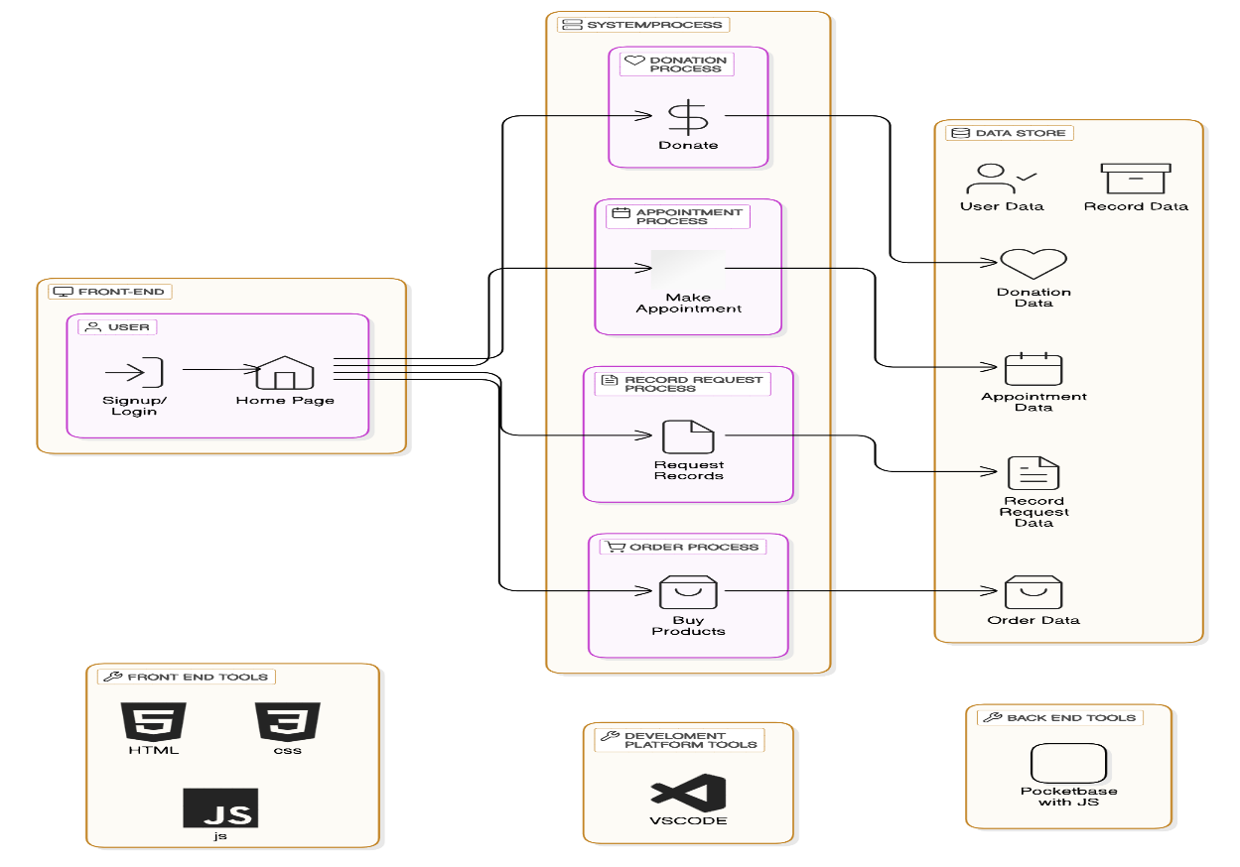

6.2 Input Design
SIGNUP
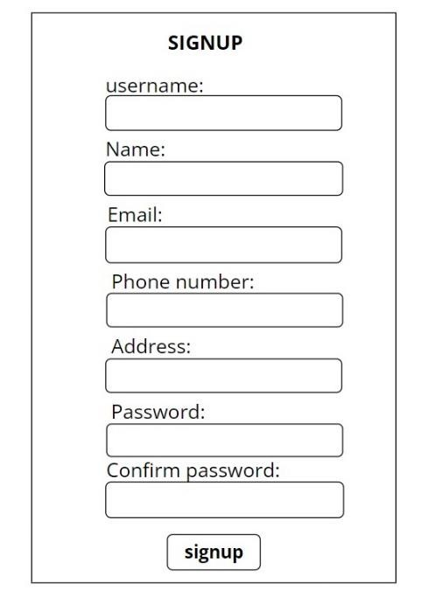

LOGIN
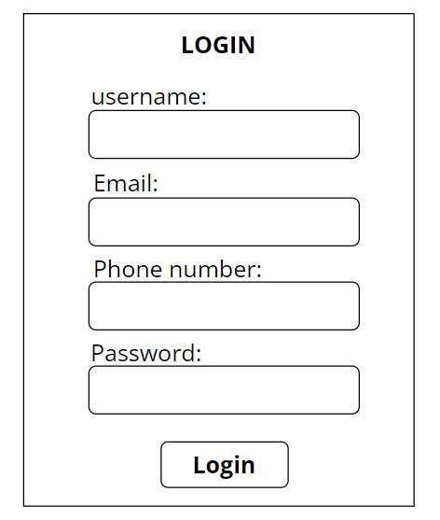

DONATION
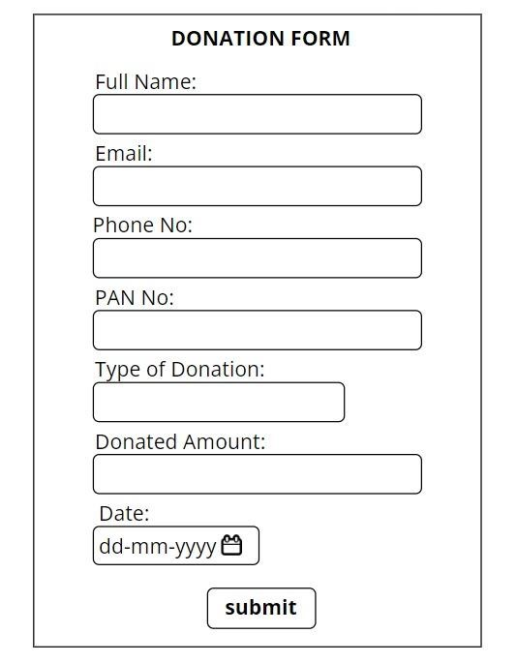

APPOINTMENT
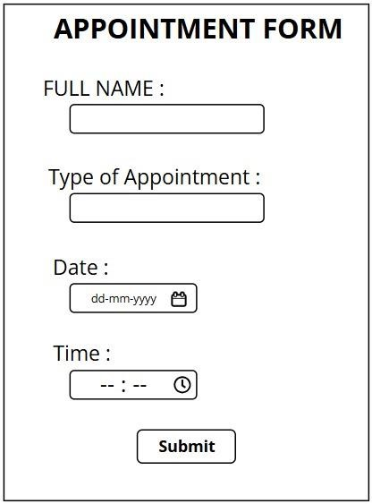

RECORD REQUEST
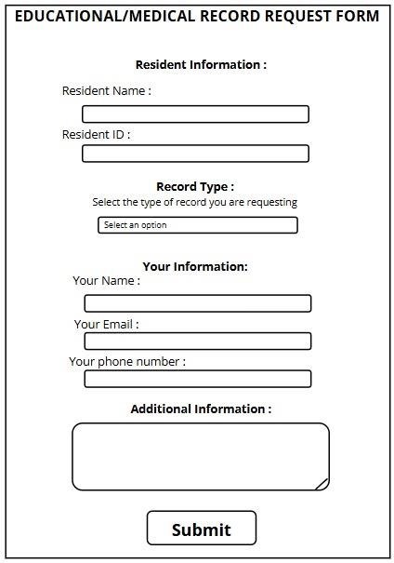

BILLING
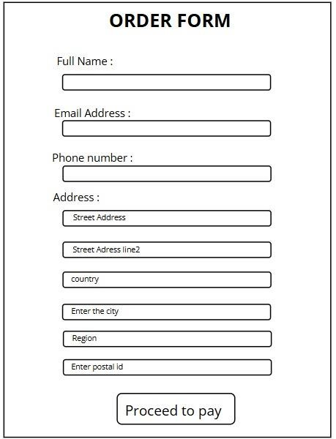

FEEDBACK
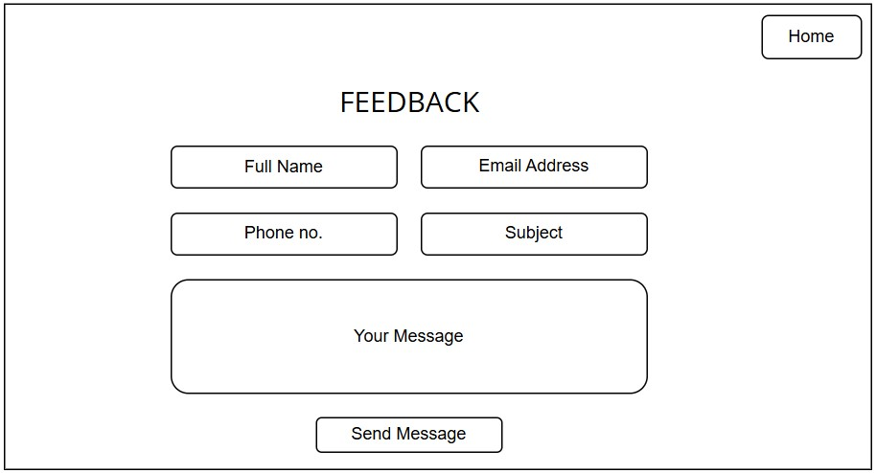

6.3 Output Design

DONATION
When the user submits the donation form with all the details, they are redirected to a page that contains the payment methods through which they can successfully pay the donated amount .
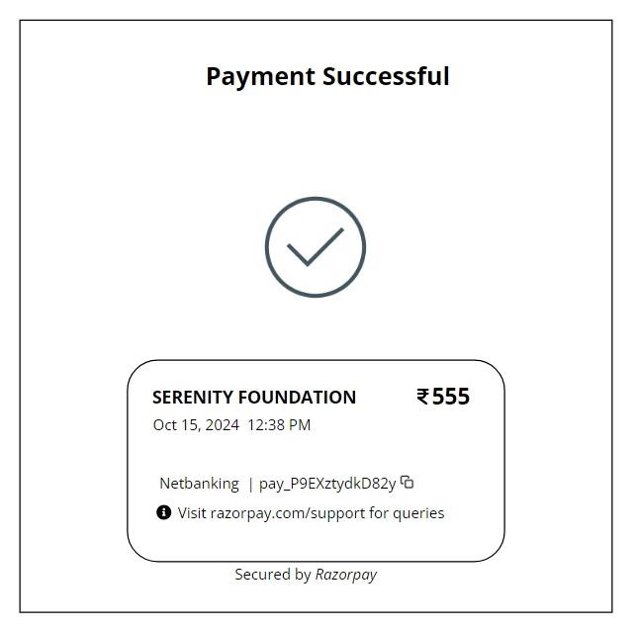

APPOINTMENT
Once the user books an appointment slot they receive an automated mail that confirms their appointment.
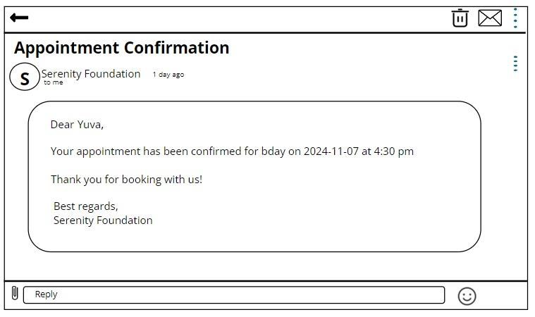

RECORD REQUEST
The user can request records of the facility residents through the record request form . Once the form is submitted
they are likely to receive the records within 3-4 working days.
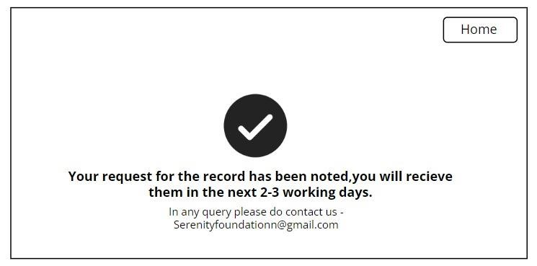

BILLING
When the user submits the billing form with all the details, they are redirected to a page that contains the payment
methods through which they can successfully pay the amount
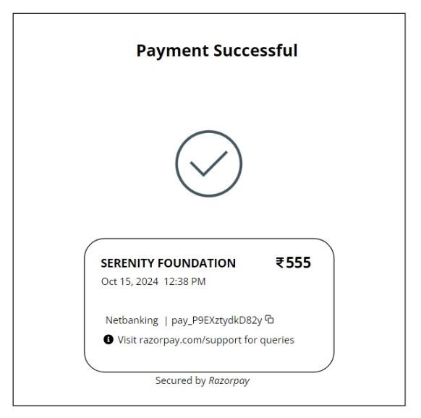

FEEDBACK
The user can submit their feedbacks about their visit or experience in the facility which will get directly mailed to the official mail id of the Foundation.

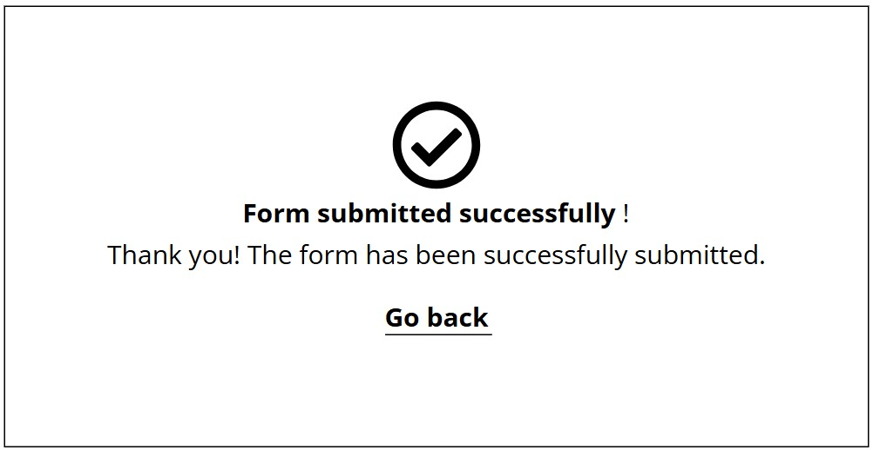

6.4 Database Design

6.4.1 Data Flow Diagram

LEVEL 0
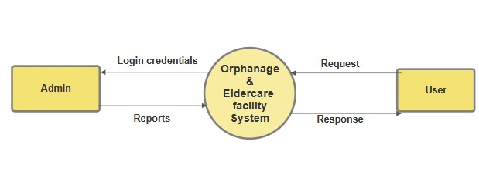

LEVEL 1

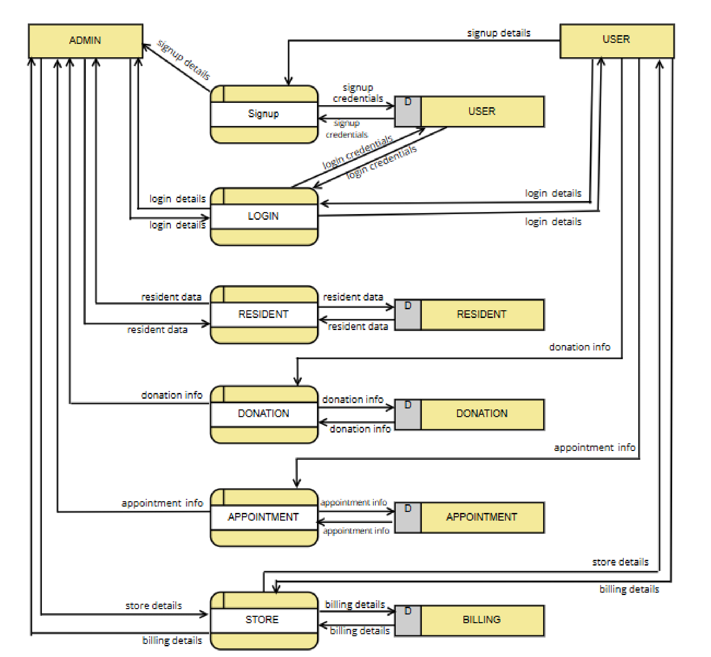

6.4.2 ER Diagram

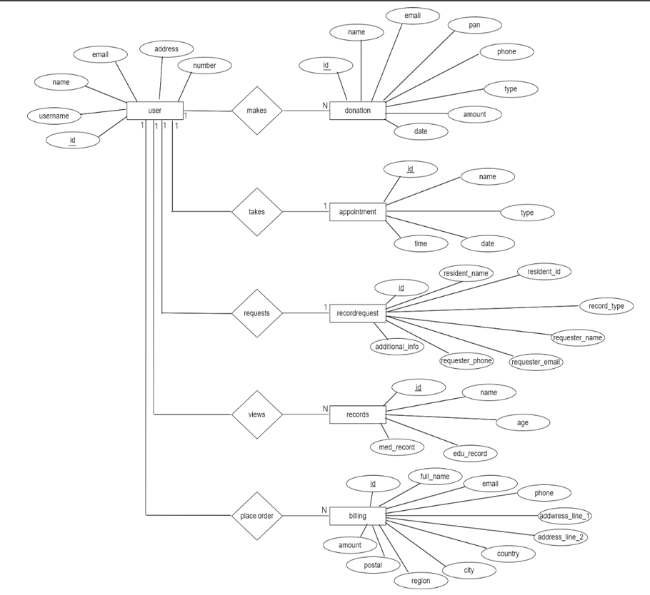

6.4.3 Table Design

USER TABLE
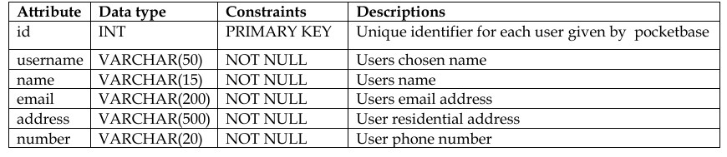

DONATION TABLE
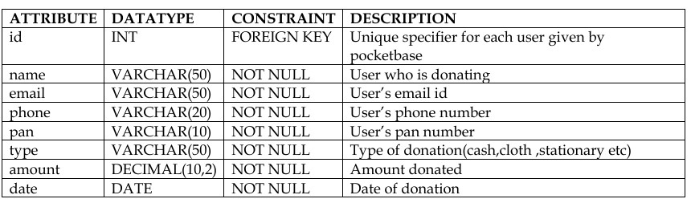

APPOINTMENT TABLE
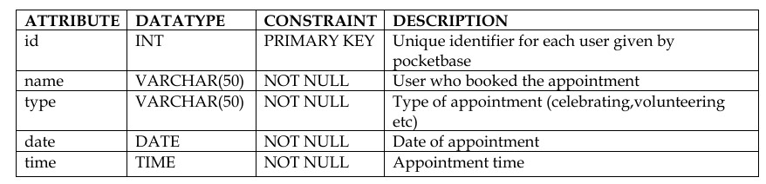

RECORD TABLE

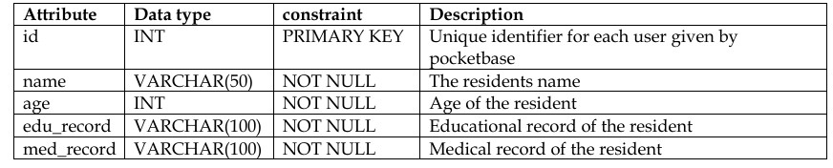

BILLING TABLE

RECORDREQUEST TABLE
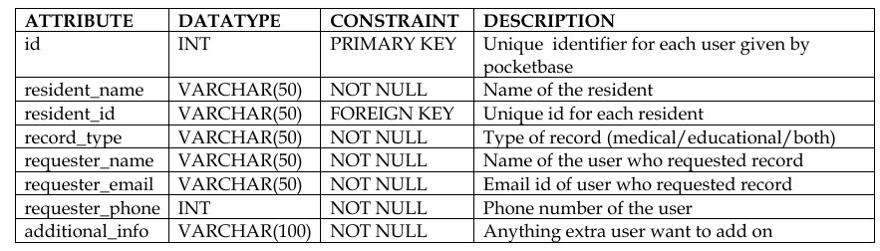

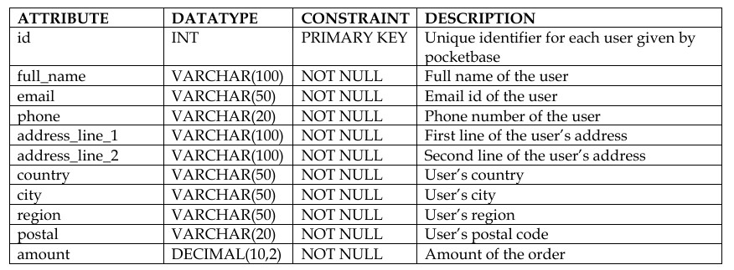

7.0 SYSTEM TESTING AND IMPLEMENTATION

7.1 System Testing
System testing is a stage of implementation which is aimed at ensuring that the system works accurately before live operation commences. Testing is vital to the success of the system. System testing makes a logical assumption that if all parts of the system are correct, the goal will be successfully achieved. The candidates systems are subjected to variety of test.
A series of test are performed for the proposed system before the system is ready for user acceptance system. The testing steps used in this project are:
•Unit testing
•Integration testing

Unit testing
It is the smallest test parts of an application or website called units are individually and independently tested for proper operation. In this testing, each modules are tested separately. In this project, we have performed unit testing on all controls to confirm that a subsystem is correctly coded and that it carries out the intended functions.

Integration testing
It is the phase in software testing in which individual software modules are combined and tested as a group. It occurs after unit testing and before validation testing. Integration testing takes as its input modules that have been unit tested ,groups them in larger aggregates , applies tests defined in an integration test plan those aggregates ,and delivers as its output the integrated system ready for system testing.In this project, we have performed integration testing on all controls to confirm that a subsystem is correctly coded and that it carries out the intended functions.

7.2 Maintenance
Software maintance is defined as the process of modifying a software system or component after delivery to correct faults, improve performance or other attributes , or adapt to a changed environment.
The stage of system development in which hardware and software are acquired developed and the installed system is tested and documented . People are trained to operate and use the system, and an organization converts to the use of newly developed system.

8.0 CONCLUSION

The proposed integrated management system will significantly enhance the operations of the orphanage and elder care facility by streamlining processes, improving data management, and providing valuable insights. By addressing the limitations of manual systems, this solution will contribute to the overall well-being of residents and staff.

9.0 SCOPE FOR FURTHER DEVELOPMENT
•If this project is extended to further development, the new version can be implemented in the form of mobile application which can be easily accessible for staff and authorized family members.
•Launch targeted fundraising campaigns with social media and email integration, tracking progress and impact in real-time.

10.0 BIBILIOGRAPHY

•www.w3schools.com
•www.tutorialspoint.com
•www.geeksforgeeks.org

11.0 APPENDIX

11.1 Screen Shots

SIGN UP
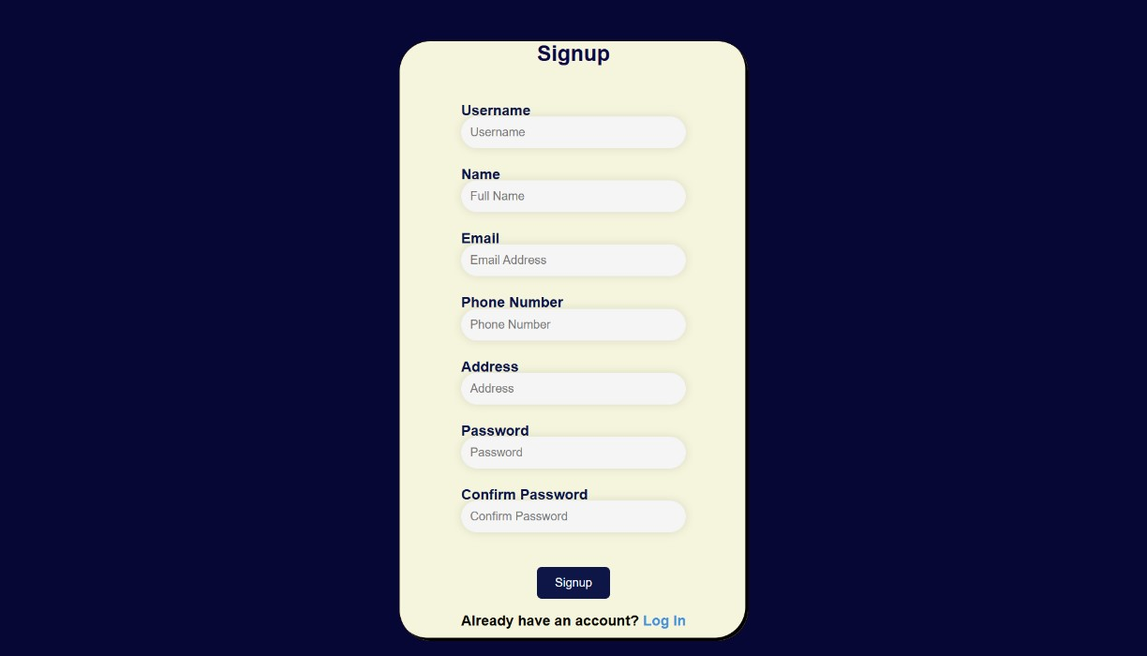

LOGIN(USER)
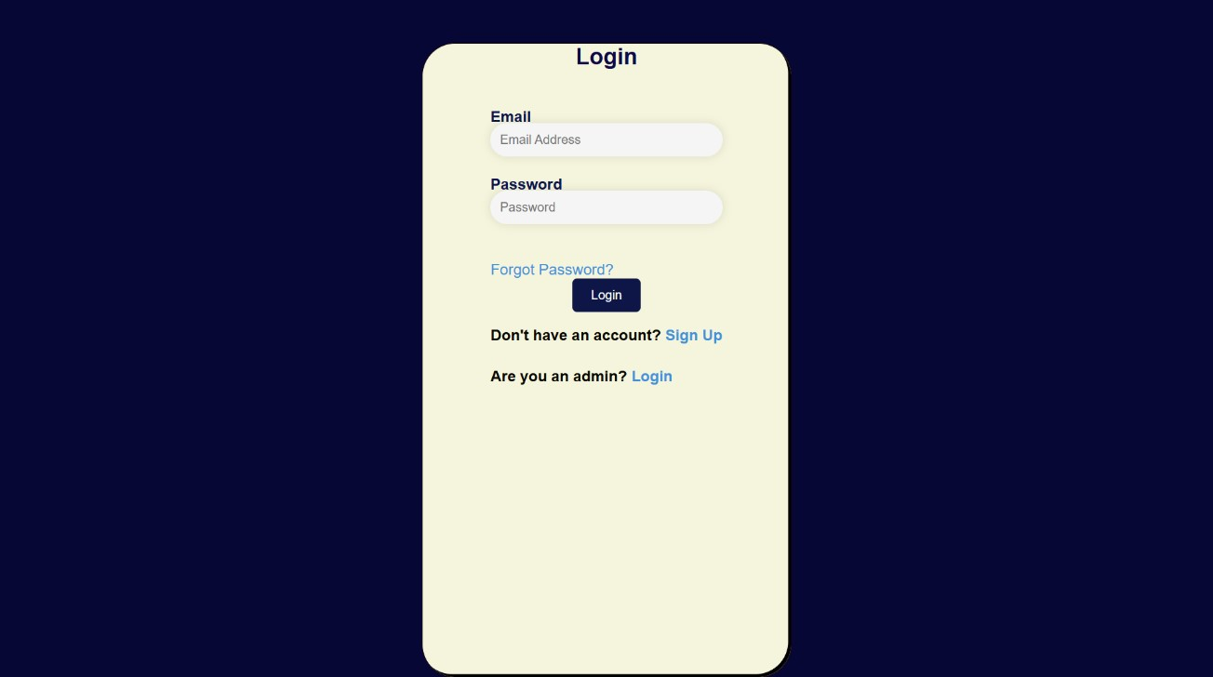
LOGIN (ADMIN)
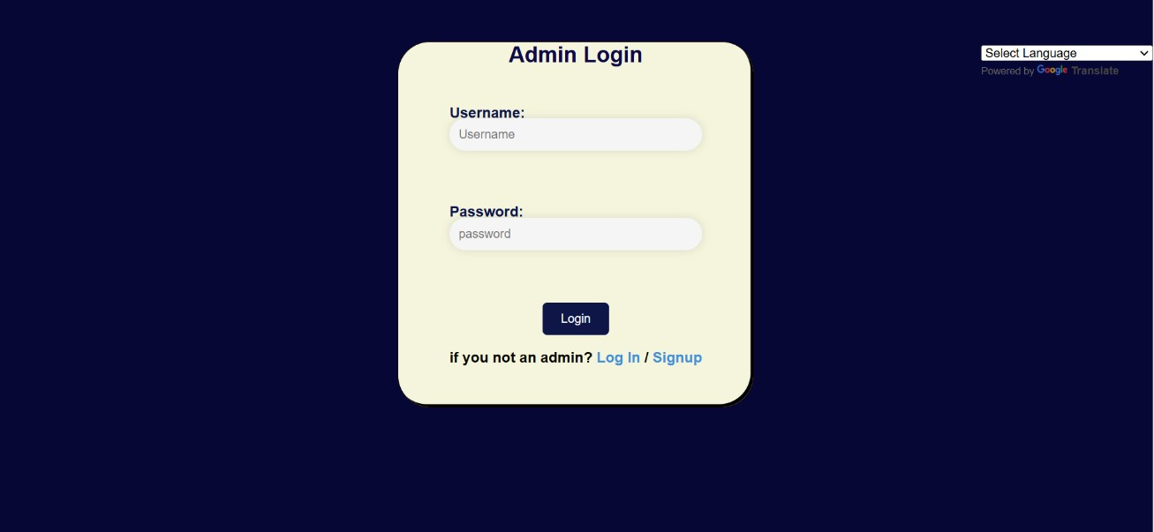

DASHBOARD (ADMIN)

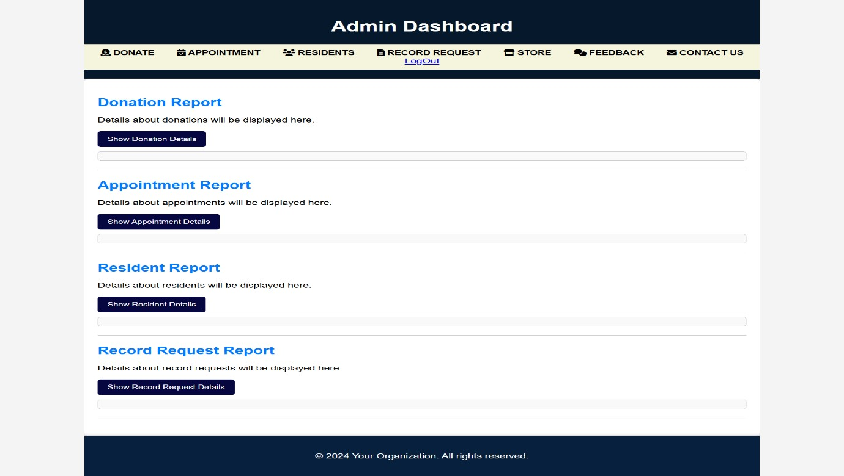

DONATION PAGE
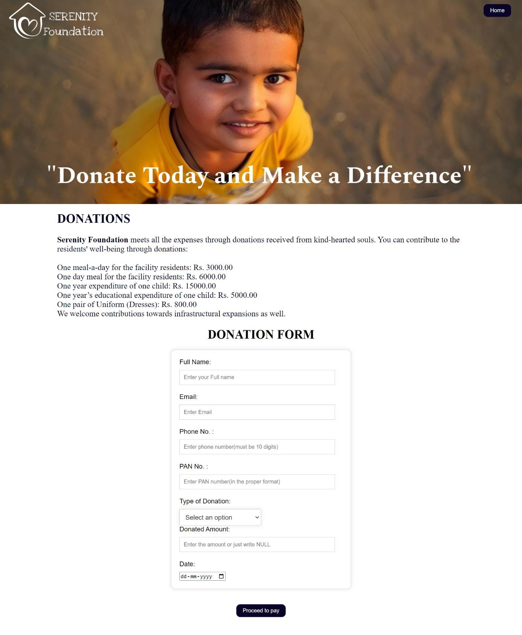

HOME PAGE
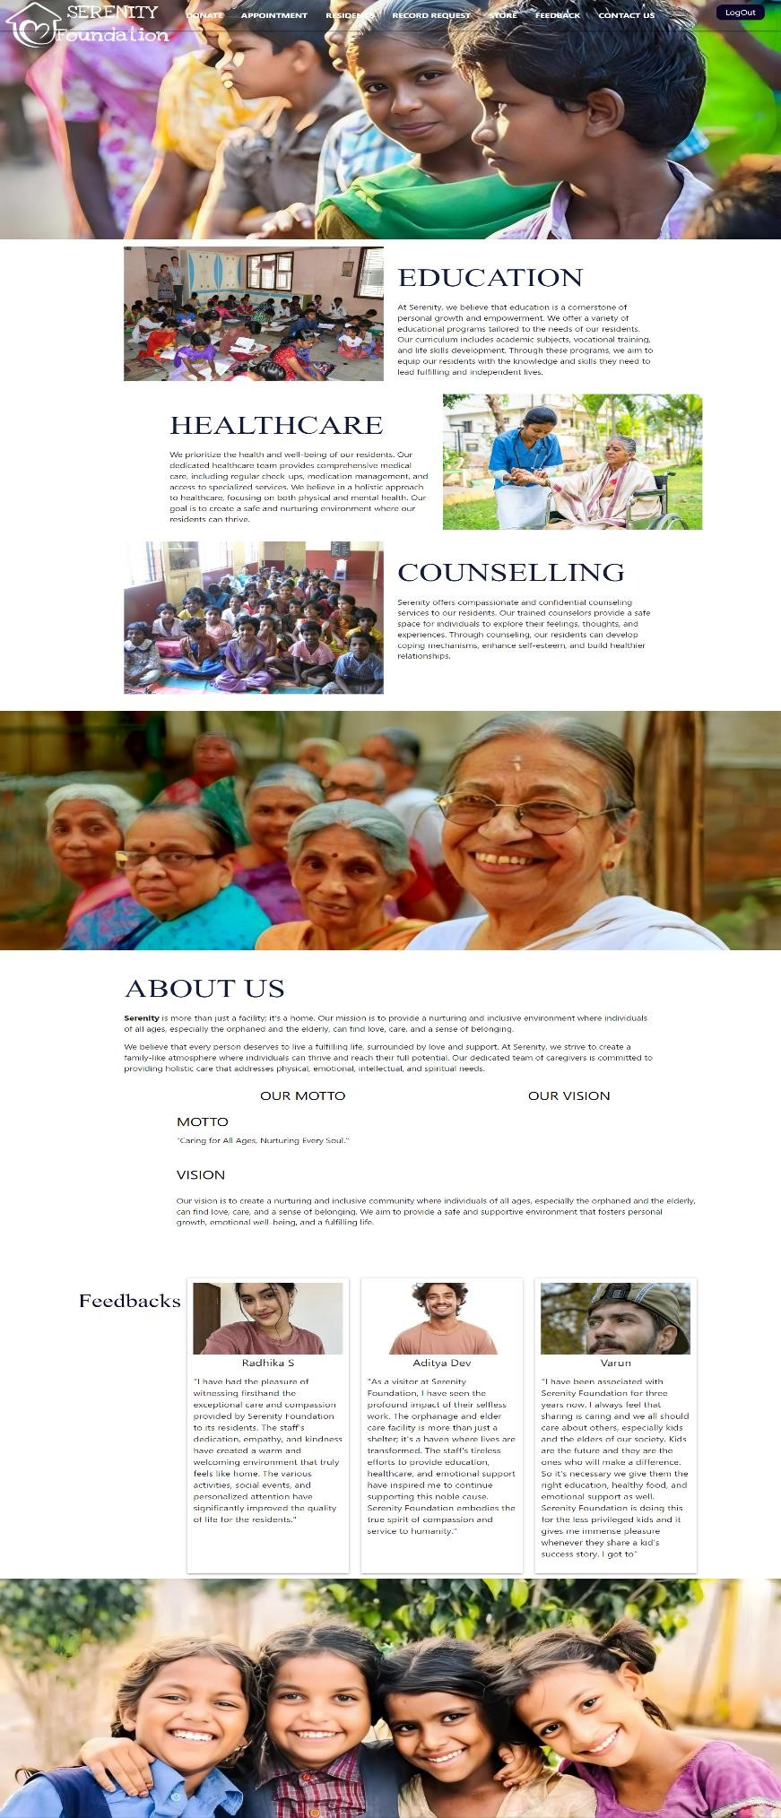
APPOINTMENT PAGE
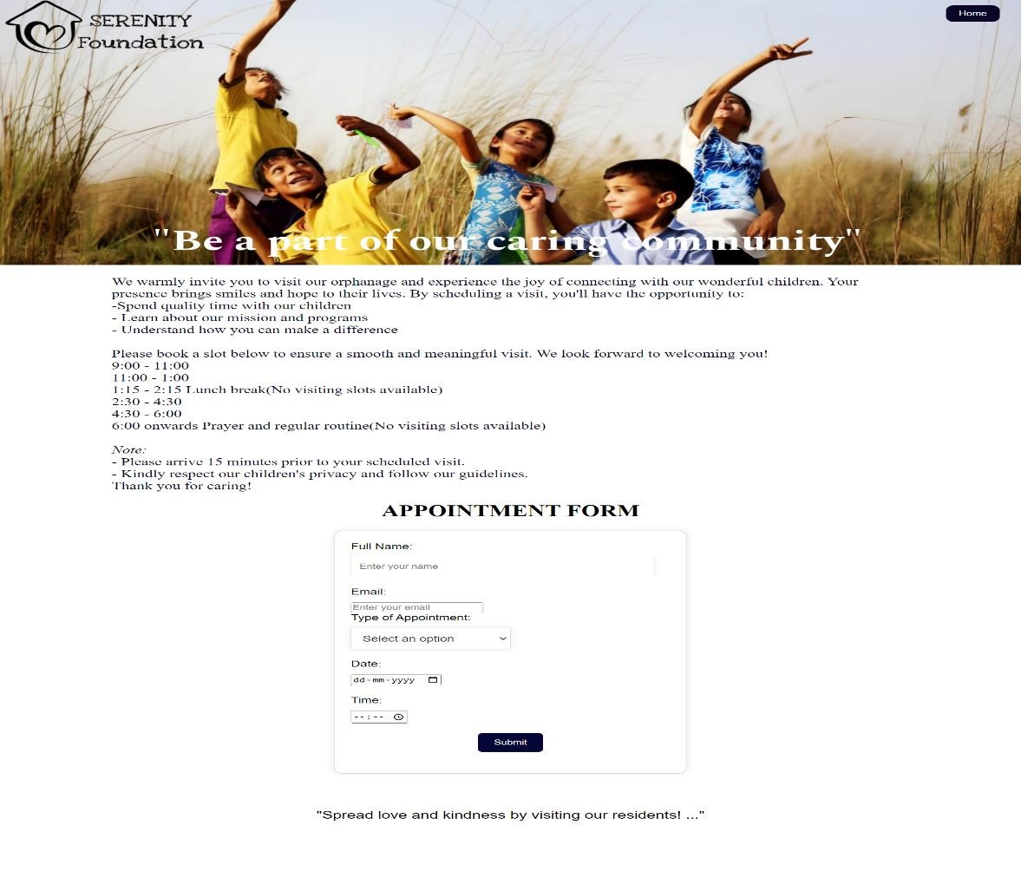
RECORD REQUEST PAGE
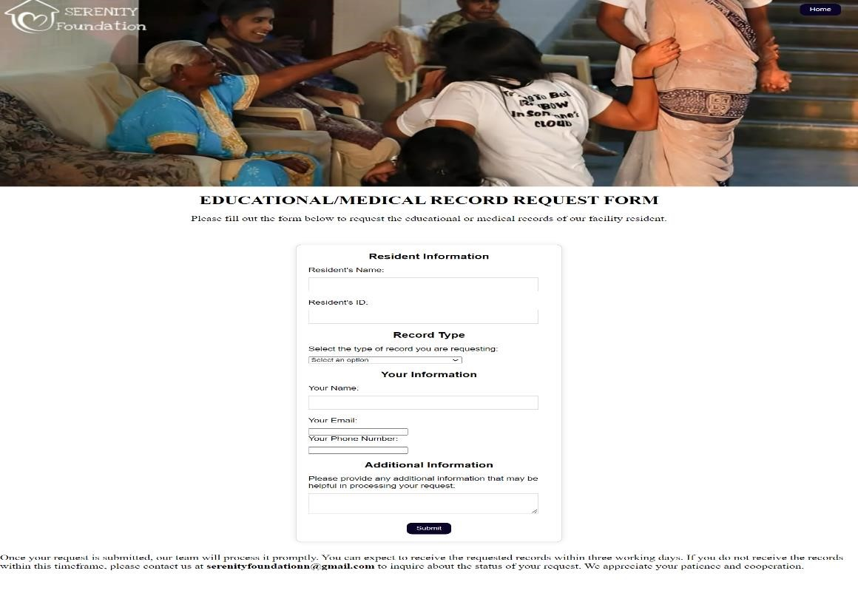

RESIDENT PAGE
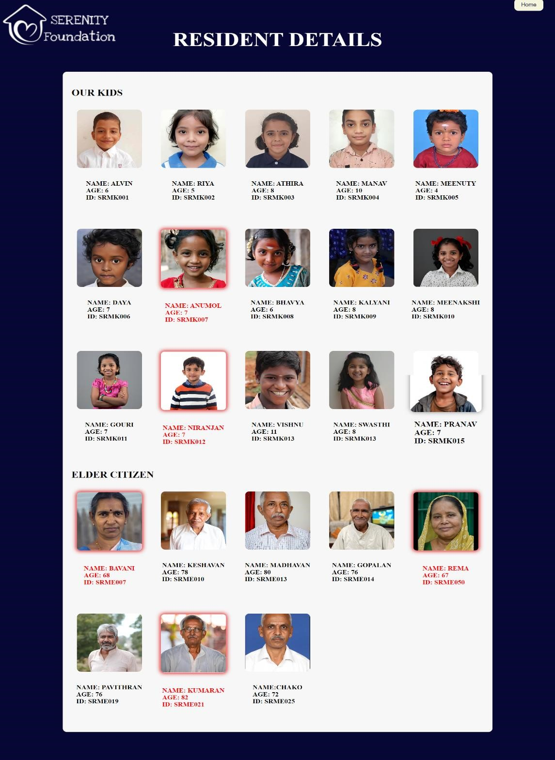

STORE PAGE
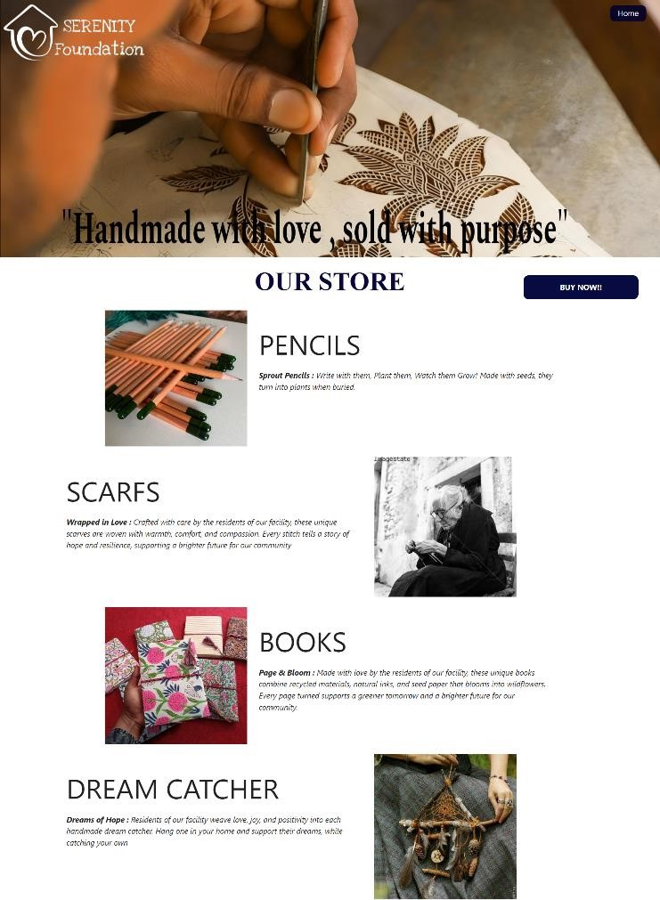
CART PAGE
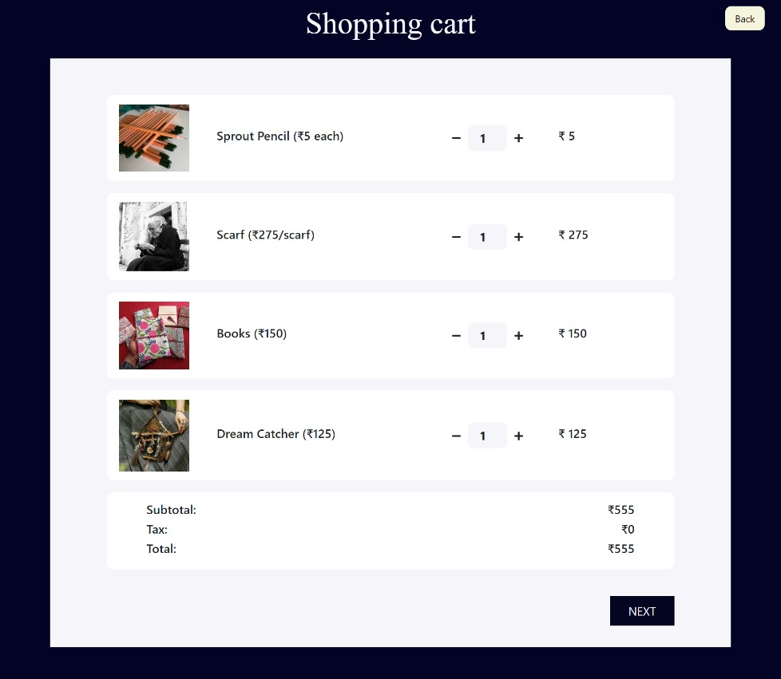
FEEDBACK PAGE
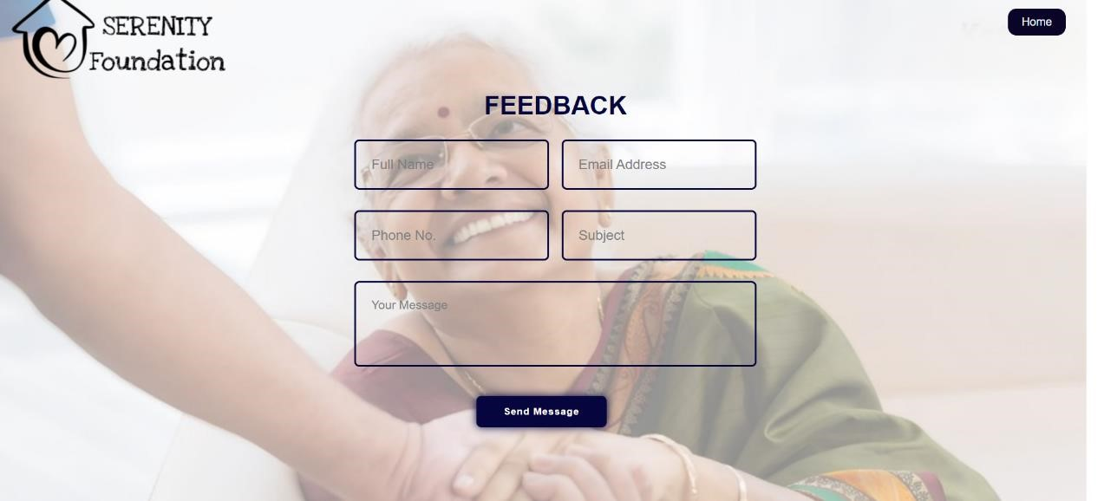

CONTACT PAGE
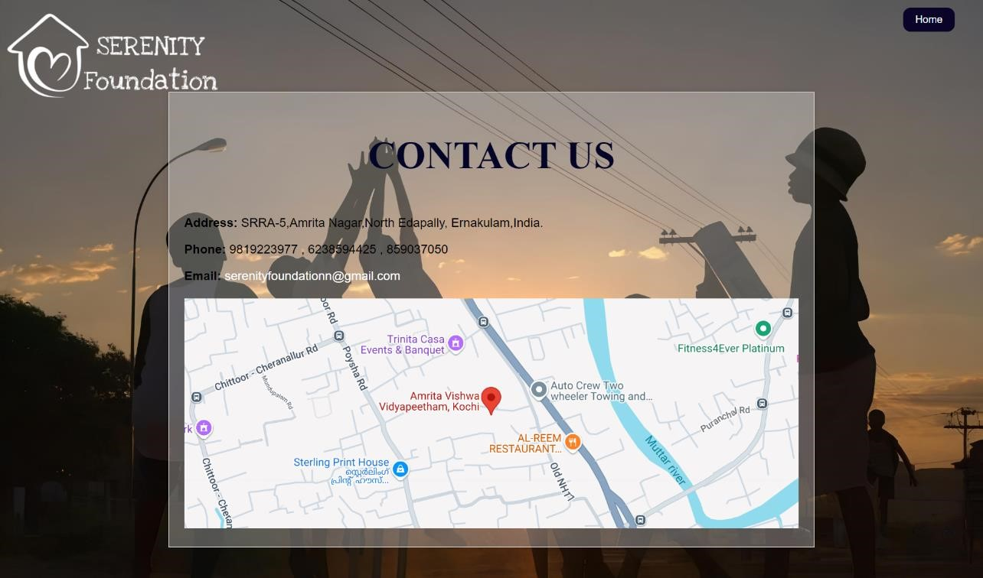

11.2 Sample Code

Home.html
<!DOCTYPE html>
<html lang="en">
<head>
<meta charset="UTF-8">
<meta http-equiv="X-UA-Compatible" content="IE=edge">
<meta name="viewport" content="width=device-width, initial-scale=1.0">
<!--Import Google Icon Font-->
<link href="https://fonts.googleapis.com/icon?family=Material+Icons" rel="stylesheet">
<!--FontAwesome icons-->
<link rel="stylesheet" href="https://pro.fontawesome.com/releases/v5.10.0/css/all.css">
<!-- Compiled and minified CSS -->
<link rel="stylesheet"
href="https://cdnjs.cloudflare.com/ajax/libs/materialize/1.0.0/css/materialize.min.css" >
<link rel="stylesheet" href="home.css">
<title>SERENITY WEBSITE</title>
<link rel="stylesheet" href="https://cdnjs.cloudflare.com/ajax/libs/font-
awesome/6.6.0/css/all.min.css" integrity="sha512-
Kc323vGBEqzTmouAECnVceyQqyqdsSiqLQISBL29aUW4U/M7pSPA/gEUZQqv1c wx4OnYxTxve5UMg5GT6L4JJg==" crossorigin="anonymous" referrerpolicy="no-
referrer" />
<!--Style-->
</head>
<!--header-->
<header>
<nav class="nav-wrapper transparent">
<div class="container">
<ul class="right hide-on-med-and-down">
<b>
<li><a href="donation1.html">DONATE</a></li>
<li><a href="appoinment.html">APPOINTMENT</a></li>
<li><a href="resident.html">RESIDENTS</a></li>
<li><a href="record.html">RECORD REQUEST</a></li>
<li><a href="store.html">STORE</a></li>
<li><a href="feedback.html">FEEDBACK</a></li>
<li><a href="contact.html">CONTACT US</a></li>
</b>
</ul>
<a href="logout.html"><button>LogOut</button></a>
</div>
</nav>
</header>
<!--img with description-->
<section class="container section">
<div class="row">
<div class="col s6 16">
<img src="edu.png" class="responsive-img materialboxed">
</div>
<div class="col s6 16">
<h2 >EDUCATION</h2>
<p>At Serenity, we believe that education is a cornerstone of personal growth and empowerment. We offer a variety of educational programs tailored to the needs of our residents. Our curriculum includes academic subjects, vocational training, and life skills development. Through these programs, we aim to equip our residents with the knowledge and skills they need to lead fulfilling and independent lives.</p>
</div>
</div>
<div class="row">
<div class="col s6 16 push-l7">
<img src="health.png" class="responsive-img materialboxed">
</div>
<div class="col s6 16 pull-l5">
<h2 >HEALTHCARE</h2>
<p>We prioritize the health and well-being of our residents. Our dedicated healthcare team provides comprehensive medical care, including regular check-ups, medication management, and access to specialized services. We believe in a holistic approach to healthcare, focusing on both physical and mental health. Our goal is to create a safe and nurturing environment where our residents can thrive.
</p>
</div>
</div>
<div class="row">
<div class="col s6 16">
<img src="counc.png" class="responsive-img materialboxed">
</div>
<div class="col s6 16">
<h2 >COUNSELLING</h2>
<p>Serenity offers compassionate and confidential counseling services to our residents. Our trained counselors provide a safe space for individuals to explore their feelings, thoughts, and experiences. Through counseling, our residents can develop coping mechanisms, enhance self-esteem, and build healthier relationships.</p>
</div>
</div>
</section>
<!--parallax 1st-->
<div class="parallax-container">
<div class="parallax">
<img src="ammuma.png" class="responsive-img">
</div>
</div>
<!--tabs-->
<section class="container section">
<div class="row">
<div class="col s13 16">
<h2 >ABOUT US</h2>
<p><b>Serenity</b> is more than just a facility; it's a home. Our mission is to provide a nurturing and inclusive environment where individuals of all ages, especially the orphaned and the elderly, can find love, care, and a sense of belonging.</p>
<p>We believe that every person deserves to live a fulfilling life, surrounded by love and support. At Serenity, we strive to create a family-like atmosphere where individuals can thrive and reach their full potential. Our dedicated team of caregivers is committed to providing holistic care that addresses physical, emotional, intellectual, and spiritual needs.</p>
</div>
<div class="col s12 16 offset-l1">
<ul class="tabs">
<li class="tab col s6">
<a href="#om" class="black-text"><h5>OUR MOTTO</h5></a>
</li>
<li class="tab col s6">
<a href="#ov" class="black-text"><h5>OUR VISION</h5></a>
</li>
</ul>
<div class="col s12" id="om">
<h4 class="flow-text black-text">MOTTO</h4>
<p>"Caring for All Ages, Nurturing Every Soul."</p>
</div>
<div class="col s12" id="ov">
<p class="flow-text black-text">VISION</p>
<p>Our vision is to create a nurturing and inclusive community where individuals of all ages, especially the orphaned and the elderly, can find love, care, and a sense of belonging. We aim to provide a safe and supportive environment that fosters personal growth, emotional well-being, and a fulfilling life.</p>
</div>
</div>
</div>
</section><br><br>
<div class="container1">
<h2 class="title">Feedbacks</h2>
<div class="card">
<img src="chechi.png" alt="Ajinder Babra">
<h3>Radhika S</h3>
<p>"I have had the pleasure of witnessing firsthand the exceptional care and compassion provided by Serenity Foundation to its residents. The staff's dedication, empathy, and kindness have created a warm and welcoming environment that truly feels like home. The various activities, social events, and personalized attention have significantly improved the quality of life for the residents."</p>
</div>
<div class="card">
<img src="etta1.png" alt="Aditya Dev">
<h3>Aditya Dev</h3>
<p>"As a visitor at Serenity Foundation, I have seen the profound impact of their selfless work. The orphanage and elder care facility is more than just a shelter; it's a haven where lives are transformed. The staff's tireless efforts to provide education, healthcare, and emotional support have inspired me to continue supporting this noble cause. Serenity Foundation embodies the true spirit of compassion and service to humanity."</p> </div>
<div class="card">
<img src="etta2.png" alt="Rosy Bairwa">
<h3>Varun</h3>
<p>"I have been associated with Serenity Foundation for three years now. I always feel that sharing is caring and we all should care about others, especially kids and the elders of our society. Kids are the future and they are the ones who will make a difference. So it's necessary we give them the right education, healthy food, and emotional support as well. Serenity Foundation is doing this for the less privileged kids and it gives me immense pleasure whenever they share a kid's success story. I got to"</p> </div>
</div>
<!--parallax 2nd-->
<div class="parallax-container">
<div class="parallax">
<img src="kuttis.png" class="responsive-img">
</div>
</div>
<!--page footer-->
<footer>
<div class="container1">
<div class="footer-content">
<h3>Contact Us</h3>
<p>Email : serenityfoundationn@gmail.com</p>
<p>Phone : 9819223977 , 6238594425 , 859037050</p>
<p>Address : SRRA-5,Amrita Nagar,North
Edapally,<br>Ernakulam,Kerela,India.</p>
</div>
<div class="footer-content">
<h3>Quick links</h3>
<ul class="list">
<li><a href="home.html">Home</a></li>
<li><a href="donation1.html">Donate</a></li>
<li><a href="appoinment.html">Appoinment</a></li>
<li><a href="resident.html">Residents</a></li>
<li><a href="record.html">Record Request</a></li>
<li><a href="store.html">Store</a></li>
<li><a href="feedback.html">Feedback</a></li>
</ul>
</div>
<div class="footer-content">
<h3>Follow Us</h3>
<ul class="social-icons">
<li><a href=""><i class="fab fa-facebook"></i></a></li>
<li><a href=""><i class="fab fa-twitter"></i></a></li>
<li><a href=""><i class="fab fa-instagram"></i></a></li> <li><a href=""><i class="fab fa-linkedin"></i></a></li>
</ul>
</div>
</div>
</footer>
<!--Compiled and minified Jquery-->
<script src="https://code.jquery.com/jquery-3.6.0.min.js"></script>
<!-- Compiled and minified JavaScript -->
<script
src="https://cdnjs.cloudflare.com/ajax/libs/materialize/1.0.0/js/materialize.min.js"></s cript>
<script src="home.js"></script>
</body>
</html>

Donation.html
<!DOCTYPE html>
<html>
<head>
<link rel=" stylesheet" type="text/css" href="donation.css">
<link rel="stylesheet" href="https://cdnjs.cloudflare.com/ajax/libs/font-
awesome/6.6.0/css/all.min.css" integrity="sha512-
Kc323vGBEqzTmouAECnVceyQqyqdsSiqLQISBL29aUW4U/M7pSPA/gEUZQqv1c wx4OnYxTxve5UMg5GT6L4JJg==" crossorigin="anonymous" referrerpolicy="no-
referrer" />
<script src="https://checkout.razorpay.com/v1/checkout.js"></script>
</head>
<header>
</header>
<body>
<br>
<div class="details">
<div class="wrapper-main">
<h4>DONATIONS</h4><br>
<p><b>Serenity Foundation</b> meets all the expenses through donations received from kind-hearted souls. You can contribute to the residents' well-being through donations:<br><br>
One meal-a-day for the facility residents: Rs. 3000.00<br>
One day meal for the facility residents: Rs. 6000.00<br>
One year expenditure of one child: Rs. 15000.00<br>
One year’s educational expenditure of one child: Rs. 5000.00<br>
One pair of Uniform (Dresses): Rs. 800.00<br>
We welcome contributions towards infrastructural expansions as well.<br><br>
</p>
</div>
</div>
<center class="title"><b>DONATION FORM</b></center>
<form action="donation1.php" method="POST">
<label for="name">Full Name:</label>
<input type="text" id="name" name="name" placeholder="Enter your Full name"><br>
<label for="email">Email:</label>
<input type="email" id="email" name="email" placeholder="Enter Email" "><br> <label for="phone">Phone No. :</label>
<input type="text" id="phone" name="phone" placeholder="Enter phone number(must be 10 digits)" pattern="[0-9]{10}"><br>
<label for="pan">PAN No. :</label>
<input type="text" id="pan" name="pan" placeholder="Enter PAN number(in the proper format)" pattern="[A-Z]{5}[0-9]{4}[A-Z]{1}"><br>
<label for="type">Type of Donation:</label>
<select id="dropdown" name="type" required>
<option value="">Select an option</option>
<option value="dress">Dress</option>
<option value="money">Money</option>
<option value="books">Books</option>
<option value="others">Support a specific resident</option><br><br>
</select>
<!-- Textfield will be added here -->
<div id="resident-name-container"></div>
<script> const dropdown = document.getElementById('dropdown'); const residentNameContainer = document.getElementById('resident-name-container'); dropdown.addEventListener('change', () => { const selectedValue = dropdown.value; if (selectedValue === 'others') { const textfield = document.createElement('input'); textfield.type = 'text'; textfield.id = 'resident-name'; textfield.name = 'resident-name';
textfield.placeholder = 'Enter the resident\'s name'; residentNameContainer.innerHTML = ''; residentNameContainer.appendChild(textfield);
} else { residentNameContainer.innerHTML = '';
}
});
</script>
<label for="amount">Donated Amount:</label>
<input type="text" id="amount" name="amount" placeholder="Enter the amount or just write NULL"><br>
<label for="date">Date:</label>
<input type="date" id="date" name="date" required><br>
</form>
<center><button id="rzp-button" class="pay">Proceed to pay</button></center>
<script> document.getElementById('rzp-button').onclick = function(e) {
e.preventDefault(); // Prevent the form from submitting var apiKey = "rzp_test_W6o3G1bafo3Ylq"; // Replace with your Razorpay API key var amount = document.getElementById('amount').value * 100; // Amount in paise
var options = {"key": apiKey,"amount": amount,"currency": "INR","name": "Serenity Foundation","description": "Donation to Serenity Foundation","image": "https://example.com/logo.png","order_id": "handler": function(response) { console.log(response);
// Update your database with the payment response
},
"prefill": {
"name": "",
"email": "",
"contact": ""
},
"notes": {
"address": "Serenity Foundation"
},
"theme": {
"color": "#F37254"
} }; var rzp1 = new Razorpay(options); rzp1.open();
e.preventDefault();
};
</script>
<nav>
<button class="home" type="button" onclick="location.href='home.html'"> Home </button>
</nav>
<!--page footer-->
<footer>
<div class="container1">
<div class="footer-content">
<h3>Contact Us</h3>
<p>Email : serenityfoundationn@gmail.com</p>
<p>Phone : 9819223977 , 6238594425 , 859037050</p>
<p>Address : SRRA-5,Amrita Nagar,North
Edapally,<br>Ernakulam,Kerela,India.</p>
</div>
<div class="footer-content">
<h3>Quick links</h3>
<ul class="list">
<li><a href="home.html">Home</a></li>
<li><a href="donation1.html">Donate</a></li>
<li><a href="appoinment.html">Appoinment</a></li>
<li><a href="resident.html">Residents</a></li>
<li><a href="record.html">Record Request</a></li>
<li><a href="store.html">Store</a></li>
<li><a href="feedback.html">Feedback</a></li>
</ul>
</div>
<div class="footer-content">
<h3>Follow Us</h3>
<ul class="social-icons">
<li><a href=""><i class="fab fa-facebook"></i></a></li>
<li><a href=""><i class="fab fa-twitter"></i></a></li>
<li><a href=""><i class="fab fa-instagram"></i></a></li>
<li><a href=""><i class="fab fa-linkedin"></i></a></li>
</ul>
</div>
</div>
</footer>
</body>
</html>

Appointment.html
<!DOCTYPE html>
<html lang="en">
<head>
<meta charset="UTF-8">
<meta name="viewport" content="width=device-width, initial-scale=1.0">
<title>Donation page</title>
<link rel="stylesheet" href="feedback.css">
<link rel="stylesheet" href="https://cdnjs.cloudflare.com/ajax/libs/font-
awesome/6.6.0/css/all.min.css" integrity="sha512-
Kc323vGBEqzTmouAECnVceyQqyqdsSiqLQISBL29aUW4U/M7pSPA/gEUZQqv1c wx4OnYxTxve5UMg5GT6L4JJg==" crossorigin="anonymous" referrerpolicy="no-
referrer" />
</head>
<body>
<section class="contact">
<h2>FEEDBACK</h2>
<form id="feedbackForm" method="POST">
<input type="hidden" name="access_key" value="04ead8b0-b025-4ff0-a80ba6fc48119fbf">
<div class="input-box">
<div class="input-field field">
<input type="text" placeholder="Full Name" id="name" class="item" autocomplete="off" required>
</div>
<div class="input-field field">
<input type="email" placeholder="Email Address" id="email" class="item" autocomplete="off" required>
</div>
</div>
<div class="input-box">
<div class="input-field field">
<input type="text" placeholder="Phone No." id="phone" class="item" autocomplete="off" required>
</div>
<div class="input-field field">
<input type="text" placeholder="Subject" id="subject" class="item" autocomplete="off" required>
</div>
</div>
<div class="textarea-field field">
<textarea id="message" cols="30" rows="10" placeholder="Your Message" class="item" autocomplete="off" required></textarea>
</div>
<button type="submit">Send Message</button>
</form>
</section>
<script src="https://smtpjs.com/v3/smtp.js"></script>
<script src="https://cdn.jsdelivr.net/npm/sweetalert2@11"></script>
<script src="contact.js"></script>
<script> function sendMessage(e) {
e.preventDefault(); // Prevent the form from submitting the traditional way // Get form values const form=document.querySelector(".feedbackForm"), name=document.querySelector(".name"), email=document.querySelector(".email"), message=document.querySelector(".message");
// Send email using SMTP.js
Email.send({
SecureToken: "f2577d01-aa7b-4423-aa5c-013e1b04f1ba ",
To: 'sweatpie789@gmail.com',
From: email.value, // Use the email variable
Subject: "Feedbackform", // Use the subject variable
Body: message.value
}).then( message => alert(message)
).catch( error => alert("Error: " + error)
);
}
</script>
<button type="button" id="buttonhome" onclick="location.href='home.html'"> Home </button>
</body>
</html>

Record.html
<!DOCTYPE html>
<html lang="en">
<head>
<meta charset="UTF-8">
<meta name="viewport" content="width=device-width, initial-scale=1.0">
<title>Recordrequest</title>
<link rel="stylesheet" type="text/css" href="record.css">
<script type="module" src="record.js"></script>
<link rel="stylesheet" href="https://cdnjs.cloudflare.com/ajax/libs/fontawesome/6.6.0/css/all.min.css" integrity="sha512-
Kc323vGBEqzTmouAECnVceyQqyqdsSiqLQISBL29aUW4U/M7pSPA/gEUZQqv1c wx4OnYxTxve5UMg5GT6L4JJg==" crossorigin="anonymous" referrerpolicy="no-
referrer" />
</head>
<header>
</header>
<body>
<br>
<center class="title"><b>EDUCATIONAL/MEDICAL RECORD REQUEST
FORM</b></center>
<div class="para">
<center><p>Please fill out the form below to request the educational or medical records of our facility resident.
</p></center><br><br>
<form id="record-request-form">
<!-- Resident information section -->
<section>
<h3>Resident Information</h3>
<label for="resident-name">Resident's Name:</label>
<input type="text" id="resident-name" name="resident-name" required pattern="[a-zA-Z ]+"><br>
<label for="resident-id">Resident's ID:</label>
<input type="text" id="resident-id" name="resident-id"><br>
</section>
<!-- Record type section -->
<section>
<h3>Record Type</h3>
<label for="record-type">Select the type of record you are requesting:</label>
<select id="record-type" name="record-type" required>
<option value="">Select an option</option>
<option value="educational">Educational Records</option>
<option value="medical">Medical Records</option>
<option value="both">Both Educational and Medical Records</option><br>
</select>
</section>
<!-- Requester information section -->
<section>
<br><h3>Your Information</h3>
<label for="requester-name">Your Name:</label>
<input type="text" id="requester-name" name="requester-name" required pattern="[a-zA-Z ]+">
<label for="requester-email">Your Email:</label>
<input type="email" id="requester-email" name="requester-email" required> <label for="requester-phone">Your Phone Number:</label>
<input type="tel" id="requester-phone" name="requester-phone" pattern="[09]{10}">
</section>
<!-- Additional information section -->
<section>
<br><h3>Additional Information</h3>
<label for="additional-info">Please provide any additional information that may be helpful in processing your request:</label>
<textarea id="additional-info" name="additional-info"></textarea>
</section>
<center><button type="submit">Submit</button></center>
</form>
</div>
<div class="para">
<p>Once your request is submitted, our team will process it promptly. You can expect to receive the requested records within three working days. If you do not receive the records within this timeframe, please contact us at
<b>serenityfoundationn@gmail.com</b> to inquire about the status of your request. We appreciate your patience and cooperation.
</p><br><br><br>
</div>
<nav>
<button class="home" type="button" onclick="location.href='home.html'"> Home </button>
</nav>
<footer>
<div class="container1">
<div class="footer-content">
<h3>Contact Us</h3>
<p>Email : serenityfoundationn@gmail.com</p>
<p>Phone : 9819223977 , 6238594425 , 859037050</p>
<p>Address : SRRA-5,Amrita Nagar,North
Edapally,<br>Ernakulam,Kerela,India.</p>
</div>
<div class="footer-content">
<h3>Quick links</h3>
<ul class="list">
<li><a href="home.html">Home</a></li>
<li><a href="donation1.html">Donate</a></li>
<li><a href="appoinment.html">Appoinment</a></li>
<li><a href="resident.html">Residents</a></li>
<li><a href="record.html">Record Request</a></li>
<li><a href="store.html">Store</a></li>
<li><a href="feedback.html">Feedback</a></li>
</ul>
</div>
<div class="footer-content">
<h3>Follow Us</h3>
<ul class="social-icons">
<li><a href=""><i class="fab fa-facebook"></i></a></li> <li><a href=""><i class="fab fa-twitter"></i></a></li>
<li><a href=""><i class="fab fa-instagram"></i></a></li>
<li><a href=""><i class="fab fa-linkedin"></i></a></li>
</ul>
</div>
</div>
</footer>
</body>
</html>

Resident.html
<!DOCTYPE html>
<html lang="en">
<head>
<meta charset="UTF-8">
<meta name="viewport" content="width=device-width, initial-scale=1.0">
<title>Resident</title>
<link rel="stylesheet" href="resident.css">
</head>
<body>
<h1><center>RESIDENT DETAILS</center></h1>
<main>
<section class="resident-info">
<div class="container">
<h2>OUR KIDS</h2>
<ul>
<!-- Kids list items -->
<li>
<img src="kid1.png" alt="Orphan 1" >
<div class="column">
<h4>NAME: ALVIN<br>
AGE: 6<br>
ID: SRMK001</h4>
</div>
</li>
<li>
<img src="kid2.png" alt="Orphan 2">
<div>
<h4>NAME: RIYA<br>
AGE: 5<br>
ID: SRMK002</h4>
</div>
</li>
<li>
<img src="kid3.png" alt="Orphan 4">
<div>
<h4>NAME: ATHIRA<br>
AGE: 8<br>

ID: SRMK003</h4>
</div>
</li>
<li>
<img src="kid4.png" alt="Orphan 4">
<div>
<h4>NAME: MANAV<br>
AGE: 10<br>
ID: SRMK004</h4>
</div>
</li>
<li>
<img src="kid5.png" alt="Orphan 5">
<div>
<h4>NAME: MEENUTY<br>
AGE: 4<br>
ID: SRMK005</h4>
</div>
</li>
<li>
<img src="kid6.png" alt="Orphan 6">
<div>
<h4>NAME: DAYA<br>
AGE: 7<br>
ID: SRMK006</h4>
</div>
</li>
<li class="emergency">
<div class="emergency-image">
<a href="red1.html">
<img src="kid8.png" alt="Emergency Image" class="redglow">
</a>
</div>
<div>
<h4>NAME: ANUMOL<br>
AGE: 7<br>
ID: SRMK007</h4>
</div>
</li>
<li>
<img src="kid7.png" alt="Orphan 8">
<div>
<h4>NAME: BHAVYA<br>
AGE: 6<br>
ID: SRMK008</h4>
</div>
</li>
<li>
<img src="kid9.png" alt="Orphan 9">
<div>
<h4>NAME: KALYANI<br>
AGE: 8<br>
ID: SRMK009</h4>
</div>
</li>
<li>
<img src="kid10.png" alt="Orphan 10">
<div>
<h4>NAME: MEENAKSHI<br>
AGE: 8<br>
ID: SRMK010</h4>
</div>
</li>
<li>
<img src="kid11.png" alt="Orphan 11">
<div>
<h4>NAME: GOURI<br>
AGE: 7<br>
ID: SRMK011</h4>
</div>
</li>
<li class="emergency">
<div class="emergency-image">
<a href="red2.html">
<img src="kid12.png" alt="Emergency Image" class="red-glow">
</a>
</div>
<div>
<h4>NAME: NIRANJAN<br>
AGE: 7<br>
ID: SRMK012</h4>
</div>
</li>
<li>
<img src="kid14.png" alt="Orphan 13">
<div>
<h4>NAME: VISHNU<br>
AGE: 11<br>
ID: SRMK013</h4>
</div>
</li>
<li>
<img src="kid13.png" alt="Orphan 14">
<div>
<h4>NAME: SWASTHI<br>
AGE: 8<br>
ID: SRMK013</h4>
</div> </li>
<li>
<img src="kid15.jpg" alt="Orphan 15">
<div>
<h3>NAME: PRANAV<br>
AGE: 7<br>
ID: SRMK015</h3>
</div>
</li>
</ul>
<h2>ELDER CITIZEN</h2>
<ul>
<li class="emergency">
<div class="emergency-image">
<a href="red3.html">
<img src="old1.png" alt="Emergency Image" class="red-glow">
</a>
</div>
<div>
<h4>NAME: BAVANI<br>
AGE: 68<br>
ID: SRME007</h4>
</div>
</li>
<li>
<img src="old2.png" alt="Elder 2">
<div>
<h4>NAME: KESHAVAN<br>
AGE: 78<br>
ID: SRME010</h4>
</div>
</li>
<li>
<img src="old3.png" alt="Elder 3">
<div>
<h4>NAME: MADHAVAN<br>
AGE: 80<br>
ID: SRME013</h4>
</div>
</li>
<li>
<img src="old4.png" alt="Elder 4">
<div>
<h4>NAME: GOPALAN<br>
AGE: 76<br>
ID: SRME014</h4>
</div>
</li>
<li class="emergency">
<div class="emergency-image">
<a href="red4.html">
<img src="old5.jpg" alt="Emergency Image" class="redglow">
</a>
</div>
<div>
<h4>NAME: REMA<br>
AGE: 67<br>
ID: SRME050</h4>
</div>
</li>
<li>
<img src="old6.png" alt="Elder 6">
<div>
<h4>NAME: PAVITHRAN<br>
AGE: 76<br>
ID: SRME019</h4>
</div>
</li>
<li class="emergency">
<div class="emergency-image">
<a href="red5.html">
<img src="old7.png" alt="Emergency Image" class="red-glow">
</a>
</div>
<div>
<h4>NAME: KUMARAN<br>
AGE: 82<br>
ID: SRME021</h4>
</div>
</li>
<li>
<img src="old8.png" alt="Elder 8">
<div>
<h4>NAME:CHAKO<br>
AGE: 72<br>
ID: SRME025</h4>
</div>
</li>
</ul>
</div>
</section>
</main>
</div>
<nav>
<button class="home" type="button" onclick="location.href='home.html'"> Home </button>
</nav>
<script src="resident.js"> </script>
</body>
</html>

Feedback.html
<!DOCTYPE html>
<html lang="en">
<head>
<meta charset="UTF-8">
<meta name="viewport" content="width=device-width, initial-scale=1.0">
<title>Donation page</title>
<link rel="stylesheet" href="feedback.css">
<link rel="stylesheet" href="https://cdnjs.cloudflare.com/ajax/libs/fontawesome/6.6.0/css/all.min.css" integrity="sha512-
Kc323vGBEqzTmouAECnVceyQqyqdsSiqLQISBL29aUW4U/M7pSPA/gEUZQqv1c wx4OnYxTxve5UMg5GT6L4JJg==" crossorigin="anonymous" referrerpolicy="no-
referrer" />
</head>
<body>
<section class="contact">
<h2>FEEDBACK</h2>
<form id="feedbackForm" method="POST">
<input type="hidden" name="access_key" value="04ead8b0-b025-4ff0-a80ba6fc48119fbf">
<div class="input-box">
<div class="input-field field">
<input type="text" placeholder="Full Name" id="name" class="item" autocomplete="off" required>
</div>
<div class="input-field field">
<input type="email" placeholder="Email Address" id="email" class="item" autocomplete="off" required>
</div>
</div>
<div class="input-box">
<div class="input-field field">
<input type="text" placeholder="Phone No." id="phone" class="item" autocomplete="off" required>
</div>
<div class="input-field field">
<input type="text" placeholder="Subject" id="subject" class="item" autocomplete="off" required>
</div>
</div>
<div class="textarea-field field">
<textarea id="message" cols="30" rows="10" placeholder="Your Message" class="item" autocomplete="off" required></textarea>
</div>
<button type="submit">Send Message</button>
</form>
</section>
<script src="https://smtpjs.com/v3/smtp.js"></script>
<script src="https://cdn.jsdelivr.net/npm/sweetalert2@11"></script>
<script src="contact.js"></script>
<script> function sendMessage(e) {
e.preventDefault(); // Prevent the form from submitting the traditional way // Get form values const form=document.querySelector(".feedbackForm"), name=document.querySelector(".name"), email=document.querySelector(".email"), message=document.querySelector(".message");
// Send email using SMTP.js
Email.send({
SecureToken: "f2577d01-aa7b-4423-aa5c-013e1b04f1ba ",
To: 'sweatpie789@gmail.com',
From: email.value, // Use the email variable
Subject: "Feedbackform", // Use the subject variable
Body: message.value
}).then( message => alert(message)
).catch( error => alert("Error: " + error)
);
}
</script>
<button type="button" id="buttonhome" onclick="location.href='home.html'"> Home </button>
</body>
</html>

Buy.html
<!DOCTYPE html>
<html>
<head>
<title>Shopping Cart</title>
<meta charset="utf-8">
<meta name="viewport" content="width=device-width, initial-scale=1">
<link href="https://cdn.jsdelivr.net/npm/bootstrap@5.0.2/dist/css/bootstrap.min.css" rel="stylesheet"
integrity="sha384-
EVSTQN3/azprG1Anm3QDgpJLIm9Nao0Yz1ztcQTwFspd3yD65VohhpuuCOmLAS
jC" crossorigin="anonymous">
<link href="https://cdnjs.cloudflare.com/ajax/libs/font-awesome/5.11.2/css/all.css" rel="stylesheet" />
<link href="buy.css" rel="stylesheet">
</head>
<body>
<section>
<div class="container">
<h2 class="px-5 p-2">Shopping cart</h2>
<div class="cart">
<div class="col-md-12 col-lg-10 mx-auto">
<div class="cart-item">
<div class="row">
<div class="col-md-7 center-item">
<img src="pencil.jpg" alt="">
<h5>Sprout Pencil (₹5 each)</h5>
</div>
<div class="col-md-5 center-item">
<div class="input-group number-spinner">
<button id="phone-minus" class="btn btn-default"><i class="fas faminus"></i></button>
<input id="phone-number" type="number" min="0" class="formcontrol text-center" value="1">
<button id="phone-plus" class="btn btn-default"><i class="fas faplus"></i></button>
</div>
<h5>₹ <span id="phone-total">5</span> </h5>
<img src="images/remove.png" alt="" class="remove-item">
</div>
</div>
</div>
<div class="cart-item">
<div class="row">
<div class="col-md-7 center-item mx-auto">
<img src="scarf.jpg" alt="">
<h5>Scarf (₹275/scarf)</h5>
</div>
<div class="col-md-5 center-item">
<div class="input-group number-spinner">
<button id="case-minus" class="btn btn-default"><i class="fas faminus"></i></button>
<input id="case-number" type="number" min="0" class="formcontrol text-center" value="1">
<button id="case-plus" class="btn btn-default"><i class="fas faplus"></i></button>
</div>
<h5>₹ <span id="case-total">275</span> </h5>
<img src="images/remove.png" alt="" class="remove-item">
</div>
</div>
</div>
<!-- Book -->
<div class="cart-item">
<div class="row">
<div class="col-md-7 center-item">
<img src="book.jpg" alt="">
<h5>Books (₹150)</h5>
</div>
<div class="col-md-5 center-item">
<div class="input-group number-spinner">
<button id="book-minus" class="btn btn-default"><i class="fas faminus"></i></button>
<input id="book-number" type="number" min="0" class="form-control text-center" value="1">
<button id="book-plus" class="btn btn-default"><i class="fas faplus"></i></button>
</div>
<h5>₹ <span id="book-total">150</span> </h5>
<img src="images/remove.png" alt="" class="remove-item">
</div>
</div>
</div>
<!-- Dreamcatcher -->
<div class="cart-item">
<div class="row">
<div class="col-md-7 center-item">
<img src="dream.jpg" alt="">
<h5>Dream Catcher (₹125)</h5>
</div>
<div class="col-md-5 center-item">
<div class="input-group number-spinner">
<button id="dream-minus" class="btn btn-default"><i class="fas faminus"></i></button>
<input id="dream-number" type="number" min="0" class="form-control text-center" value="1">
<button id="dream-plus" class="btn btn-default"><i class="fas faplus"></i></button>
</div>
<h5>₹ <span id="dream-total">125</span> </h5>
<img src="images/remove.png" alt="" class="remove-item">
</div>
</div>
</div>
<div class="cart-item">
<div class="row g-2">
<div class="col-6">
<h5>Subtotal: </h5>
<h5>Tax:</h5>
<h5>Total:</h5>
</div>
<div class="col-6 status">
<h5>₹<span id="sub-total">555</span></h5>
<h5>₹<span id="tax-amount">0</span></h5>
<h5>₹<span id="total-price">555</span></h5>
</div>
</div>
</div>
<div class="col-md-12 pt-4 pb-4">
<button class="check-out">NEXT</button>
</div>
</div>
</div>
</div>
</section>
<script src="buy.js"></script>
<nav>
<button class="home" type="button" onclick="location.href='store.html'">Back</button>
</nav>
<input type="hidden" id="total-amount" value="" />
</body>
</html>

Buy.js document.querySelector('.check-out').addEventListener('click', () => { // Update the value of the #total-amount element with the total amount
document.getElementById('total-amount').value = document.getElementById('total-price').textContent;

const totalAmount = document.getElementById('total-amount').value; localStorage.setItem('totalAmount', totalAmount);

// Redirect to k.html window.location.href = 'billing.html';
});
function updateProductQuantity(product, price, isIncreasing) { const productInput = document.getElementById(product + '-number'); let productQuantity = productInput.value;
if (isIncreasing) {
productQuantity = parseInt(productQuantity) + 1;
} else if (productQuantity > 0) { productQuantity = parseInt(productQuantity) - 1;
}
productInput.value = productQuantity;

// Update product total price const productTotal = document.getElementById(product + '-total'); productTotal.innerText = productQuantity * price;
calculateTotal();
}

// Get product quantity function getInputValue(product) { const productInput = document.getElementById(product + '-number'); const productQuantity = parseInt(productInput.value); return productQuantity;
}

// Calculate total price function calculateTotal() { const phoneQuantity = getInputValue('phone'); const caseQuantity = getInputValue('case'); const bookQuantity = getInputValue('book'); const dreamQuantity = getInputValue('dream');

const phoneTotal = phoneQuantity * 5; const caseTotal = caseQuantity * 275; const bookTotal = bookQuantity * 150; const dreamTotal = dreamQuantity * 125; const subTotal = phoneTotal + caseTotal + bookTotal + dreamTotal; const tax = subTotal / 10; const totalPrice = subTotal + tax;

// Update prices on the HTML document.getElementById('sub-total').innerText = subTotal; document.getElementById('tax-amount').innerText = tax; document.getElementById('total-price').innerText = totalPrice;
}

// Add event listeners for each product
document.getElementById('case-plus').addEventListener('click', function() { updateProductQuantity('case', 275, true);
});

document.getElementById('case-minus').addEventListener('click', function() { updateProductQuantity('case', 275, false);
});

document.getElementById('phone-plus').addEventListener('click', function() { updateProductQuantity('phone', 5, true);
});
document.getElementById('phone-minus').addEventListener('click', function() { updateProductQuantity('phone', 5, false);
});

document.getElementById('book-plus').addEventListener('click', function() { updateProductQuantity('book', 150, true);
});

document.getElementById('book-minus').addEventListener('click', function() { updateProductQuantity('book', 150, false);
});

document.getElementById('dream-plus').addEventListener('click', function() { updateProductQuantity('dream', 125, true);
});

document.getElementById('dream-minus').addEventListener('click', function() {
updateProductQuantity('dream', 125, false);
});

